**Error Document**

**1.** 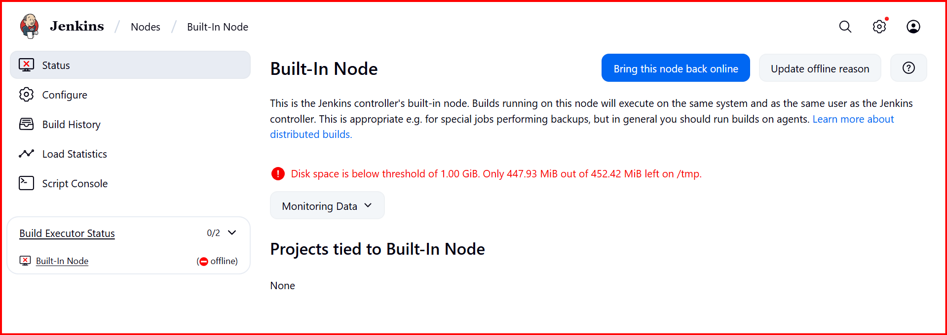

Sloution make it as 100Mb

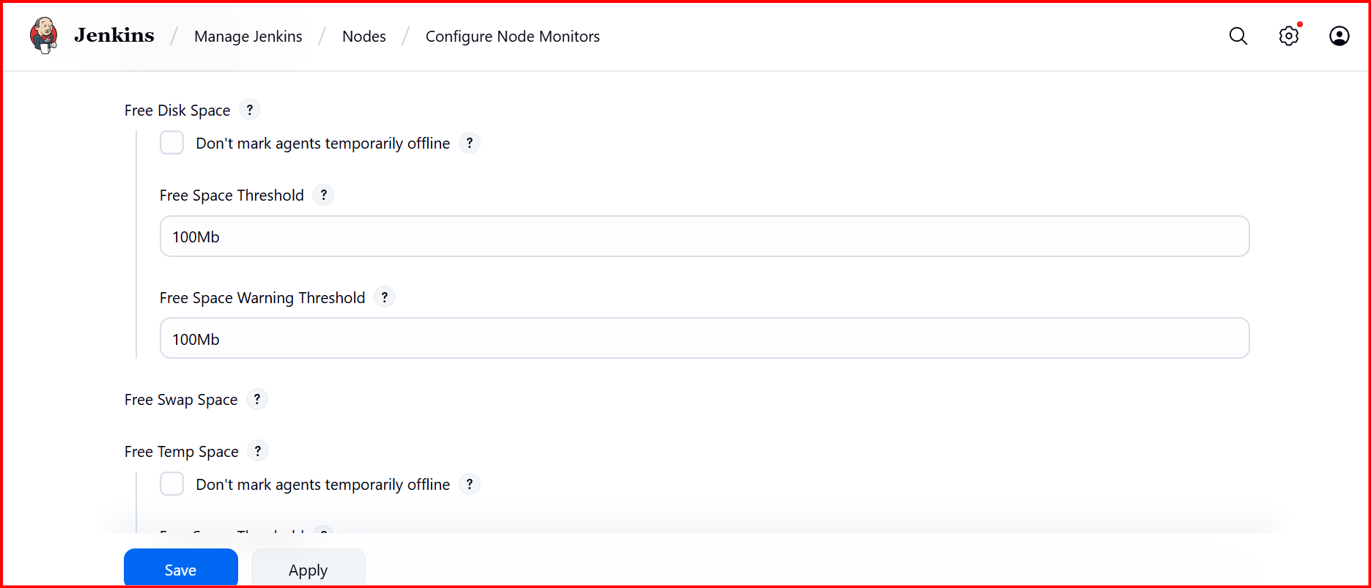

**2. In webhooks iam attaching payload its throwing error**

Last delivery was not successful. Invalid HTTP Response: 302.

**Solution**:

While instating the Jenkins need to change the password

Open Jenkins in browser: http://54.196.69.104:8080/  
→ Login with your admin password (/var/lib/jenkins/secrets/initialAdminPassword).

3. 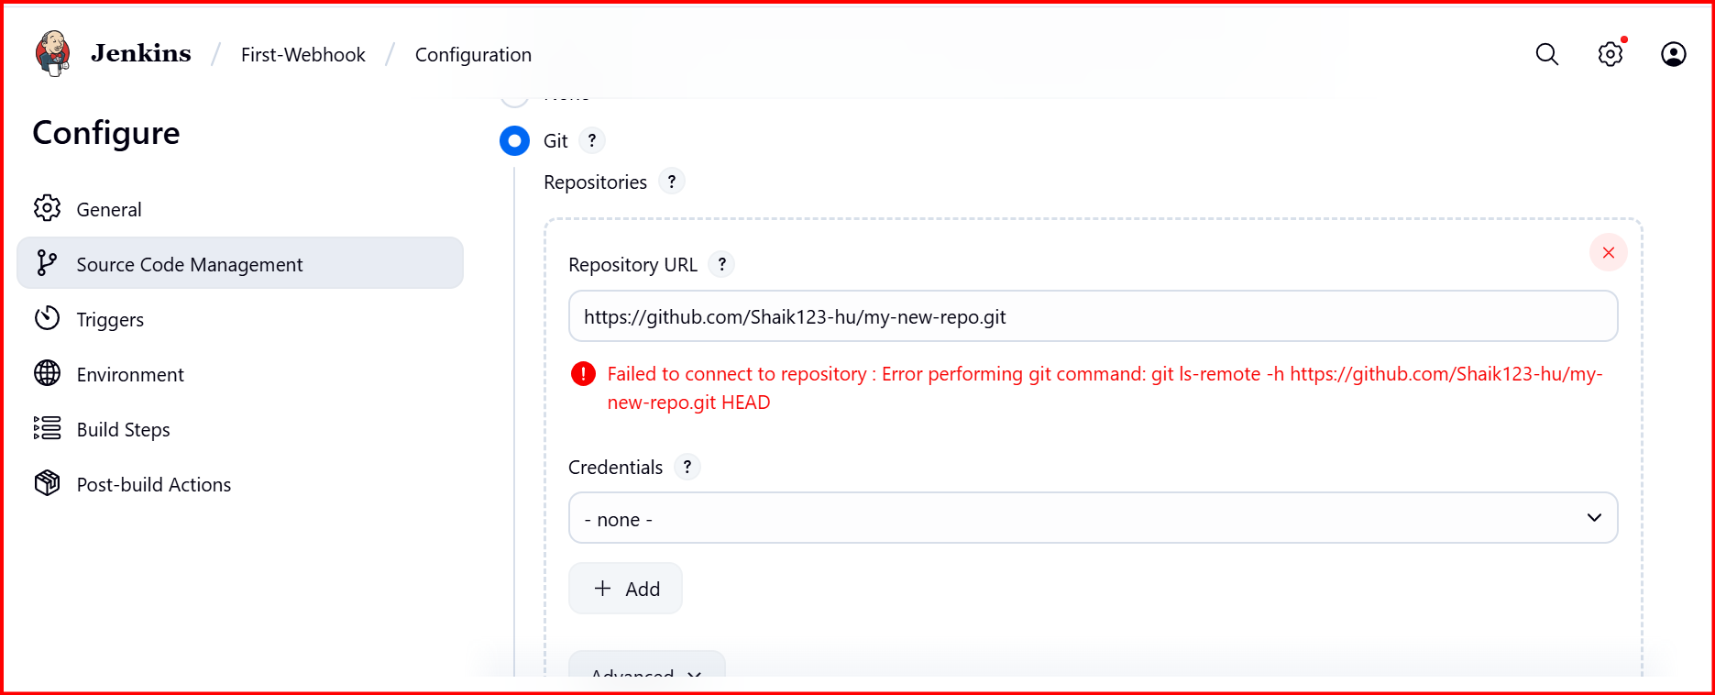

Install git in server

4. I have install all the everything for the sonarqube

Install java, Mysql, sonarqube all the things install and ssh also connect the ssh this disconnected from the server

I have taken t3 small, because my account is free plan, I don’t have option to choose the t2 large

After that I have choosen c7large.

Then the error has been resolved.

5. 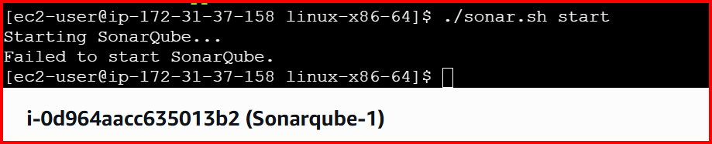

Change the permissions

Sudo chown -R ec2-user:ec2-user sonar